Welcome To
Trinity Lutheran Church
Lutheran Church—Missouri Synod
A Stephen Ministry Congregation
1354 South Otsego Avenue
Gaylord, Michigan 49735
Church Phone: (989) 732-4816

Church Email: secretary@trinitygaylord.com
www.trinitygaylord.com
Office Hours: Monday through Friday 9am – 1pm

OUR PURPOSE
…is to LOVE GOD, LOVE OTHERS, AND SERVE THE WORLD by worshiping the Lord Jesus, bringing our members into Christ-like maturity, and equipping them through Word and Sacrament for their mission and ministry. We go heart to heart into the world with Jesus, sharing His love, caring for one another, praying, and bringing the lost into a relationship with Christ, by the working of the Holy Spirit.

February 22, 2023
Ash Wednesday
Preacher: Rev. Ken Bernthal

ABOUT OUR WORSHIP
We welcome all who gather here today! We are blessed to celebrate together the mercy, grace, and love we have from God through the death and resurrection of our Lord Jesus Christ.

Children: Families with children are very welcome here. Having children in church is important so they can begin to learn about their faith in Jesus, and it’s good for the whole congregation to see. Please feel comfortable keeping “squirmy” kids in the service. This is where they belong, too!

Pew Cards: Guests and Members, please fill out the Guest/Member card located on the back of the pew in front of you and pass it to the end of the aisle. If you forget you can put it in the offering plate on your way out.

If standing is difficult: Please feel free to remain seated during any portion of the service. Please let an Elder or Usher know if you need communion in your pew seat.

About our celebration of Holy Communion: We celebrate the Lord’s Supper in the confession and glad confidence that, as he says, our Lord gives into our mouths not only bread and wine but his very body and blood to eat and to drink for the forgiveness of sins and to strengthen our union with him and with one another. Our Lord invites to his table those who trust his words, repent of all sin, and set aside any refusal to forgive and love as he forgives and loves us, that they may show forth his death until he comes.

Because those who eat and drink our Lord’s body and blood contrary to that which is stated above do so to their great harm, and also because Holy Communion is a confession of the faith which is confessed at this altar. Anyone who is not yet instructed, in doubt, or who hold a confession differing from that of the Lutheran Church—Missouri Synod, and yet desire to receive the sacrament, are asked first to speak with Pastor. Those not communing are still invited to come forward for a blessing from Pastor, and you may indicate this by crossing your arms over your chest.
TTTTTT
GREETING

P Peace be with you.
C And also with you.

T ORDER OF SERVICE T
(The liturgy is from Divine Service Setting four LSB pg. 203ff)

OPENING HYMN
Were You There LSB 456
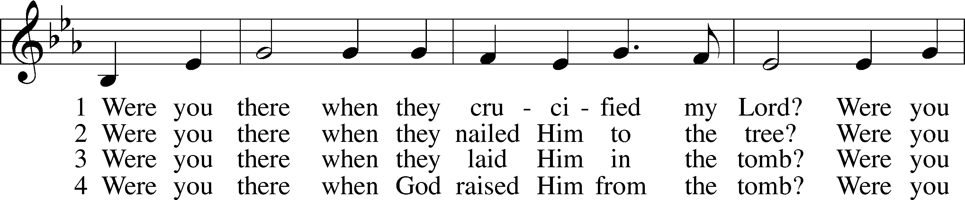
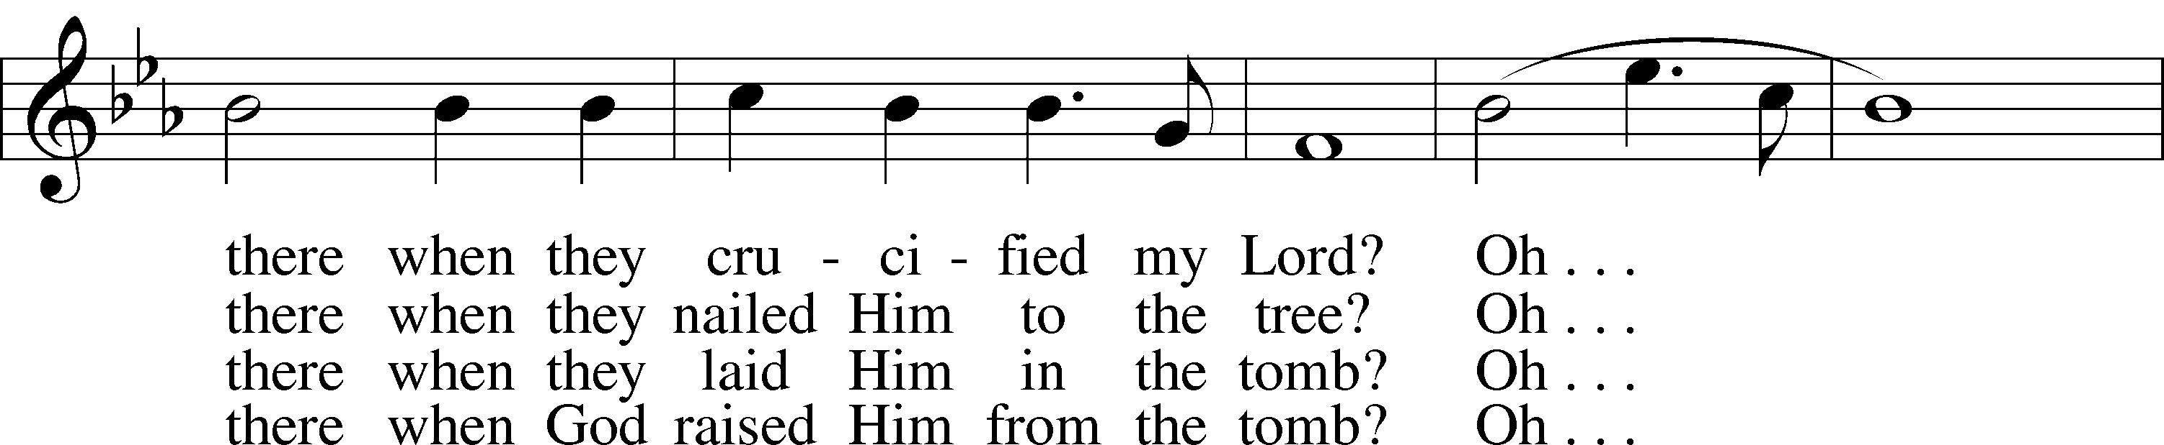
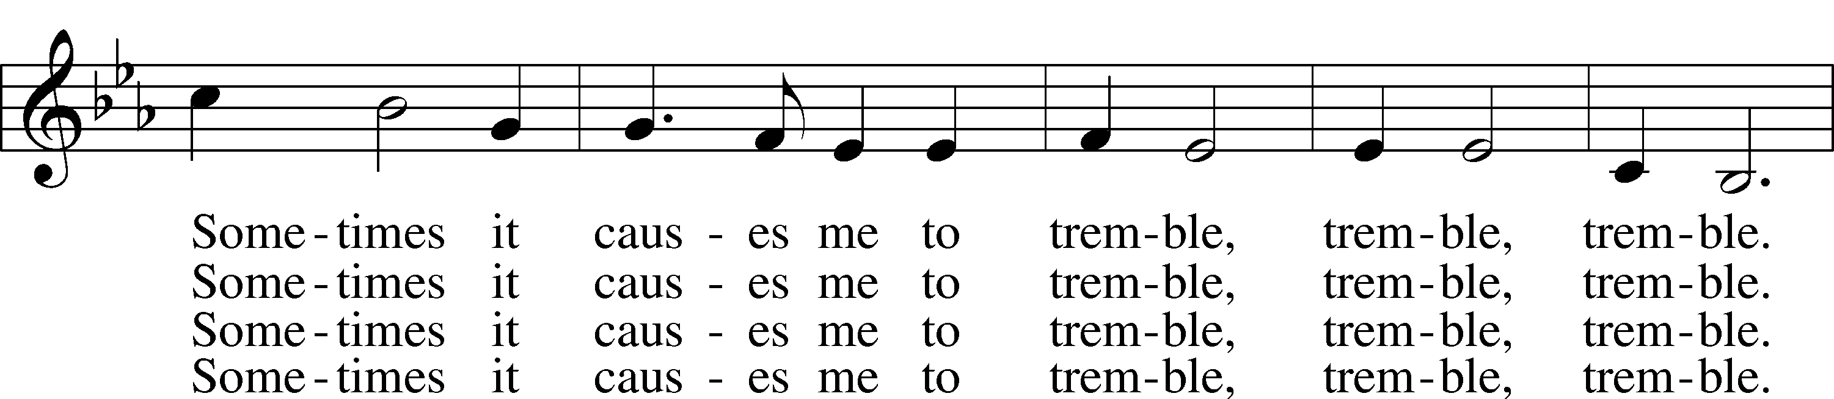
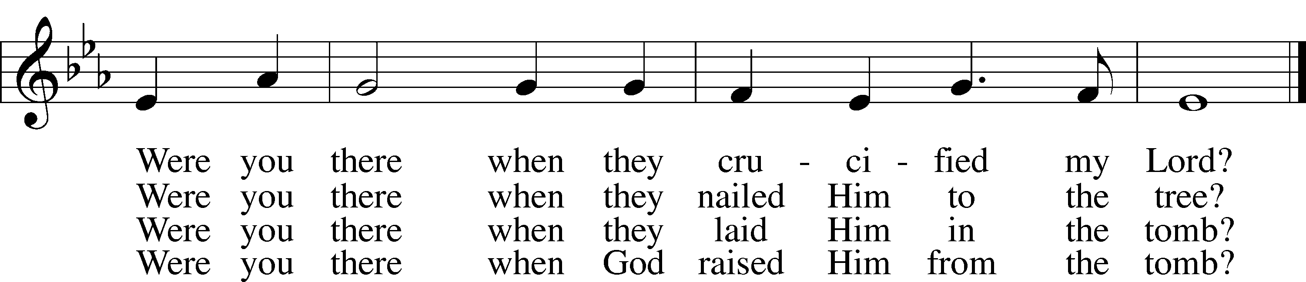

DEPOSITION OF ASHES

CONFESSION and ABSOLUTION
The sign of the cross may be made by all in remembrance of their Baptism.

P In the name of the Father and of the T Son and of the Holy Spirit.
C Amen.
P Our help is in the name of the Lord,
C who made heaven and earth.
P If You, O Lord, kept a record of sins, O Lord, who could stand?
C But with You there is forgiveness; therefore You are feared.

P Since we are gathered to hear God’s Word, call upon Him in prayer and praise, and receive the body and blood of our Lord Jesus Christ in the fellowship of this altar, let us first consider our unworthiness and confess before God and one another that we have sinned in thought, word, and deed, and that we cannot free ourselves from our sinful condition. Together as His people let us take refuge in the infinite mercy of God, our heavenly Father, seeking His grace for the sake of Christ, and saying: God, be merciful to me, a sinner.
C Almighty God, have mercy upon us, forgive us our sins, and lead us to everlasting life. Amen.

P Almighty God, merciful Father, in Holy Baptism You declared us to be Your children and gathered us into Your one, holy Church, in which You daily and richly forgive us our sins and grant us new life through Your Spirit. Be in our midst, enliven our faith, and graciously receive our prayer and praise; through Your Son, Jesus Christ, our Lord.
C Amen.
T SERVICE OF THE WORD T
INTROIT Psalm 51:1–3, 10–12; antiphon: v. 17
P The sacrifices of God are a broken spirit;
a broken and contrite heart, O God, you will not despise.
C Have mercy on me, O God, according to your steadfast love;
according to your abundant mercy blot out my transgressions.
P Wash me thoroughly from my iniquity,
and cleanse me from my sin!
C For I know my transgressions,
and my sin is ever before me.
P Create in me a clean heart, O God,
and renew a right spirit within me.
C Cast me not away from your presence,
and take not your Holy Spirit from me.
P Restore to me the joy of your salvation,
and uphold me with a willing spirit.
A Glory be to the Father and to the Son
and to the Holy Spirit;
as it was in the beginning,
is now, and will be forever. Amen.
P The sacrifices of God are a broken spirit;
a broken and contrite heart, O God, you will not despise.

KYRIE LSB 204
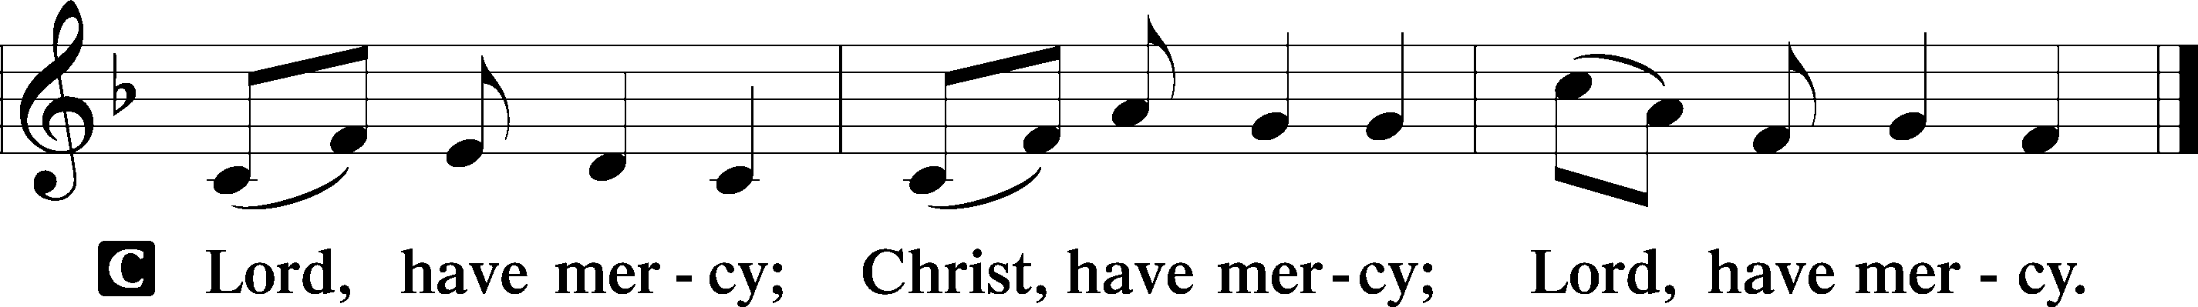

SALUTATION AND COLLECT OF THE DAY
P The Lord be with you.
C And also with you.

P Let us pray.
Almighty and everlasting God, You despise nothing You have made and forgive the sins of all who are penitent. Create in us new and contrite hearts that lamenting our sins and acknowledging our wretchedness we may receive from You full pardon and forgiveness; through Jesus Christ, Your Son, our Lord, who lives and reigns with You and the Holy Spirit, one God, now and forever.
C Amen.

Please be seated
OLD TESTAMENT READING Joel 2:12–19
¹²“Yet even now,” declares the Lord ,“return to me with all your heart,
with fasting, with weeping, and with mourning;
¹³and rend your hearts and not your garments .”Return to the Lord, your God,
for he is gracious and merciful, slow to anger, and abounding in steadfast love;
and he relents over disaster.
¹⁴Who knows whether he will not turn and relent,and leave a blessing behind him,
a grain offering and a drink offering for the Lord your God?
¹⁵Blow the trumpet in Zion; consecrate a fast; call a solemn assembly;
¹⁶gather the people. Consecrate the congregation; assemble the elders;
gather the children, even nursing infants. Let the bridegroom leave his room,
and the bride her chamber.
¹⁷Between the vestibule and the altar let the priests, the ministers of the Lord, weep
and say, “Spare your people, O Lord, and make not your heritage a reproach,
a byword among the nations Why should they say among the peoples,
‘Where is their God?’”
¹⁸Then the Lord became jealous for his land and had pity on his people.
¹⁹The Lord answered and said to his people, “Behold, I am sending to you
grain, wine, and oil, and you will be satisfied; and I will no more make you
a reproach among the nations.”
P This is the Word of the Lord.
C Thanks be to God.

EPISTLE 2 Corinthians 5:20b—6:10
We implore you on behalf of Christ, be reconciled to God. ²¹For our sake he made him to be sin who knew no sin, so that in him we might become the righteousness of God.
¹Working together with him, then, we appeal to you not to receive the grace of God in vain. ²For he says,
“In a favorable time I listened to you,
and in a day of salvation I have helped you.”
Behold, now is the favorable time; behold, now is the day of salvation. ³We put no obstacle in anyone’s way, so that no fault may be found with our ministry, ⁴but as servants of God we commend ourselves in every way: by great endurance, in afflictions, hardships, calamities, ⁵beatings, imprisonments, riots, labors, sleepless nights, hunger; ⁶by purity, knowledge, patience, kindness, the Holy Spirit, genuine love; ⁷by truthful speech, and the power of God; with the weapons of righteousness for the right hand and for the left; ⁸through honor and dishonor, through slander and praise. We are treated as impostors, and yet are true; ⁹as unknown, and yet well known; as dying, and behold, we live; as punished, and yet not killed; ¹⁰as sorrowful, yet always rejoicing; as poor, yet making many rich; as having nothing, yet possessing everything.

P This is the Word of the Lord.
C Thanks be to God.

VERSE
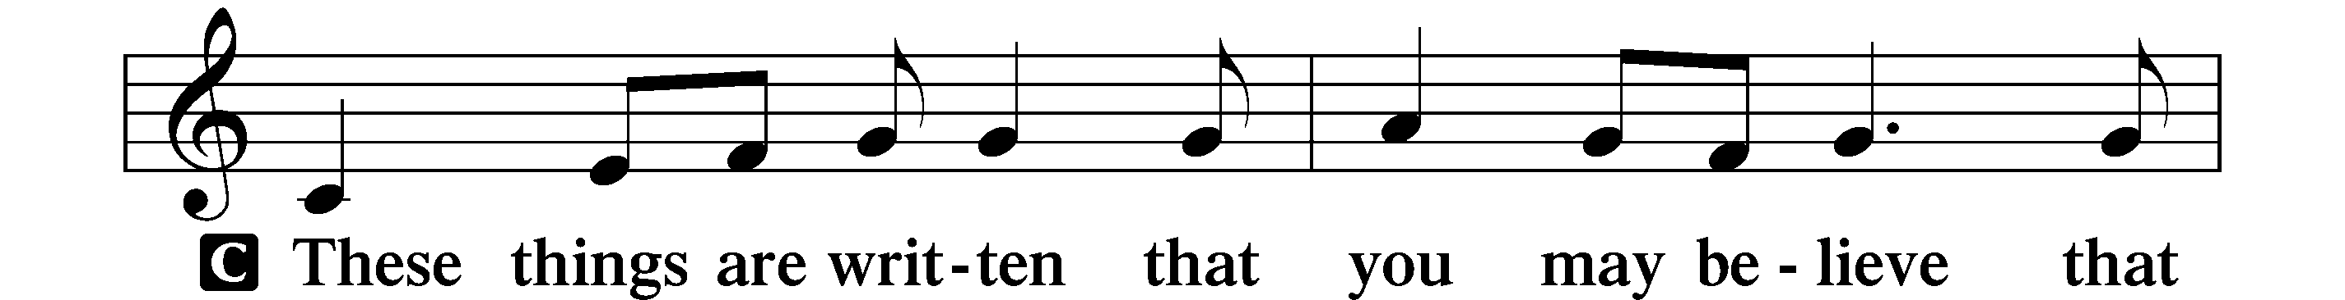
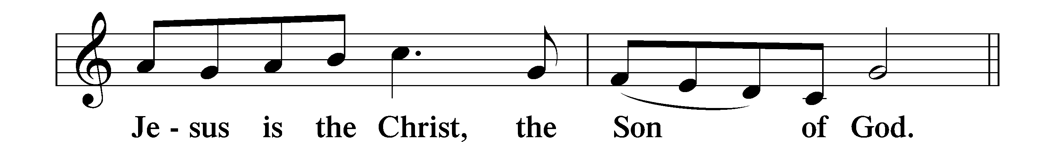

HOLY GOSPEL John 11:45–53
P The Holy Gospel according to St. John, the eleventh chapter.
C Glory to You, O Lord.

⁴⁵Many of the Jews therefore, who had come with Mary and had seen what he did, believed in him, ⁴⁶but some of them went to the Pharisees and told them what Jesus had done. ⁴⁷So the chief priests and the Pharisees gathered the Council and said, “What are we to do? For this man performs many signs. ⁴⁸If we let him go on like this, everyone will believe in him, and the Romans will come and take away both our place and our nation.” ⁴⁹But one of them, Caiaphas, who was high priest that year, said to them, “You know nothing at all. ⁵⁰Nor do you understand that it is better for you that one man should die for the people, not that the whole nation should perish.” ⁵¹He did not say this of his own accord, but being high priest that year he prophesied that Jesus would die for the nation, ⁵²and not for the nation only, but also to gather into one the children of God who are scattered abroad. ⁵³So from that day on they made plans to put him to death.

P This is the Gospel of the Lord.
C Praise to You, O Christ.

NICENE CREED
C I believe in one God,
the Father Almighty,
maker of heaven and earth
and of all things visible and invisible.
And in one Lord Jesus Christ,
the only-begotten Son of God,
begotten of His Father before all worlds
God of God, Light of Light,
very God of very God,
begotten, not made,
being of one substance with the Father,
by whom all things were made;
who for us men and for our salvation came down from heaven
and was incarnate by the Holy Spirit of the virgin Mary
and was made man;
and was crucified also for us under Pontius Pilate.
He suffered and was buried.
And the third day He rose again according to the Scriptures
and ascended into heaven
and sits at the right hand of the Father.
And He will come again with glory to judge both the living and the dead,
whose kingdom will have no end.
And I believe in the Holy Spirit,
the Lord and giver of life,
who proceeds from the Father and the Son,
who with the Father and the Son together is worshiped and glorified,
who spoke by the prophets.
And I believe in one holy Christian and apostolic Church,
I acknowledge one Baptism for the remission of sins,
and I look for the resurrection of the dead
and the life T of the world to come. Amen.

Please be seated

SERMON HYMN
Glory Be to Jesus LSB 433
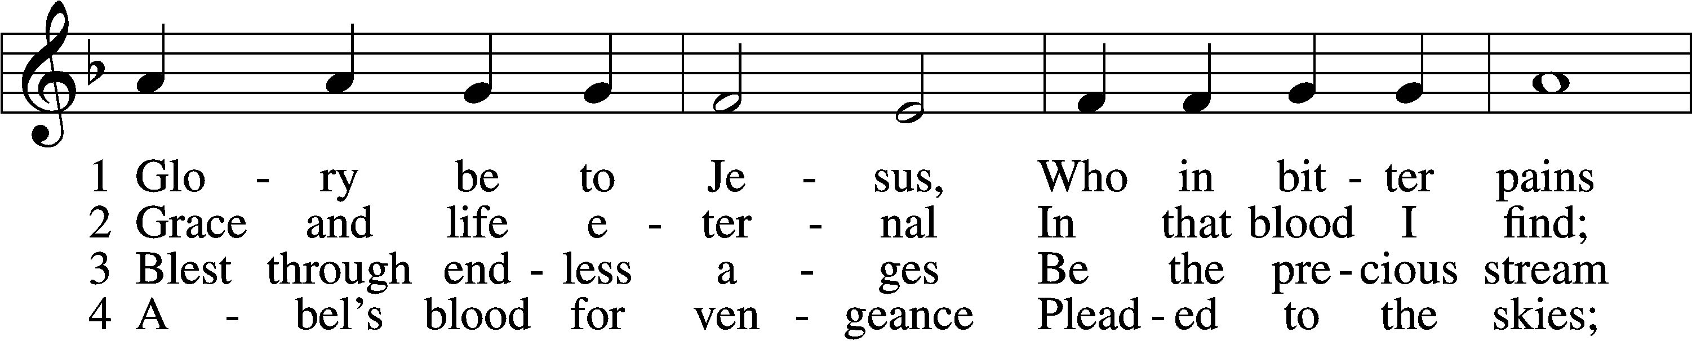
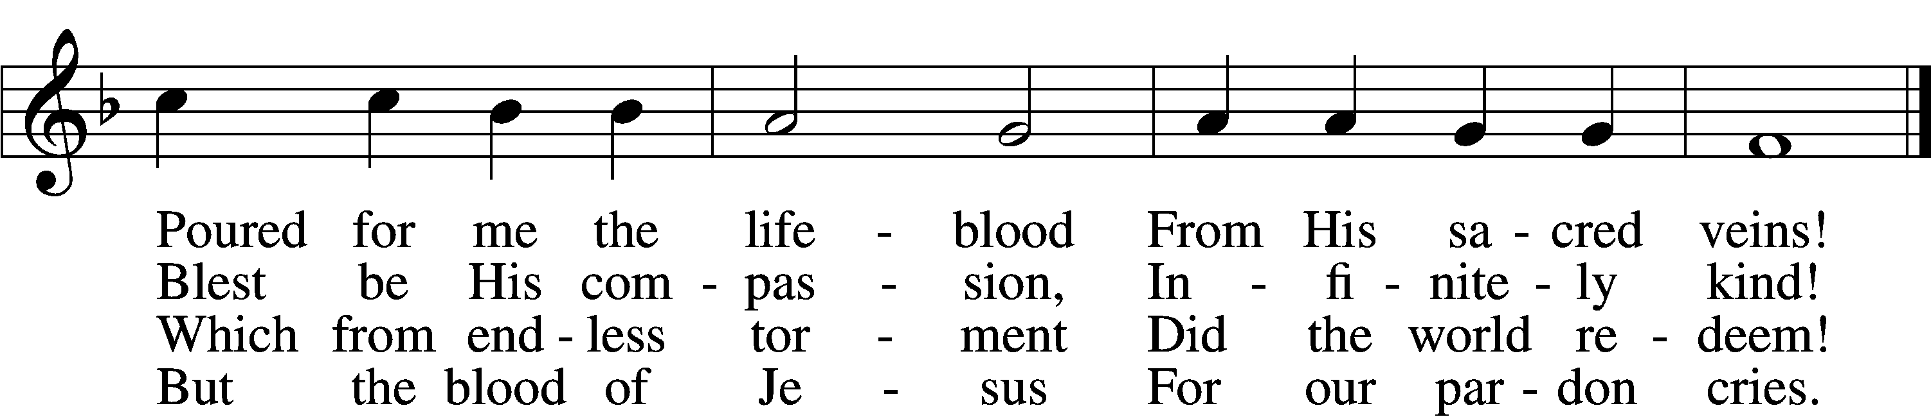

5 Oft as earth exulting
Wafts its praise on high,
Angel hosts rejoicing
Make their glad reply.

6 Lift we, then, our voices,
Swell the mighty flood;
Louder still and louder
Praise the precious blood!

SERMON “CAIAPHAS, WERE YOU THERE?”
Please stand as able
PRAYER of the CHURCH
After each Segment:
P Lord, in Your Mercy,
C Hear our Prayer.
Final Segment:
P Hear us as we pray in His name and as He has taught us:

LORD’S PRAYER
Our Father who art in heaven,
Hallowed be thy name,
Thy kingdom come,
Thy will be done
On earth as it is in heaven.
Give us this day our daily bread;
And forgive us our trespasses
As we forgive those
Who trespass against us;
And lead us not into temptation,
But deliver us from evil.
For thine is the kingdom
And the power and the glory
Forever and ever. Amen

PREFACE LSB 208

P The Lord be with you.
C And also with you.

P Lift up your hearts.
C We lift them to the Lord.

P Let us give thanks to the Lord our God.
C It is right to give Him thanks and praise.

P It is truly good, right, and salutary that we should at all times and in all places give thanks to You, O Lord, holy Father, almighty and everlasting God, for the countless blessings You so freely bestow on us and all creation. Above all, we give thanks for Your boundless love shown to us when You sent Your only-begotten Son, Jesus Christ, into our flesh and laid on Him our sin, giving Him into death that we might not die eternally. Because He is now risen from the dead and lives and reigns to all eternity, all who believe in Him will overcome sin and death and will rise again to new life. Therefore with angels and archangels and with all the company of heaven we laud and magnify Your glorious name, evermore praising You and singing:

SANCTUS LSB 208
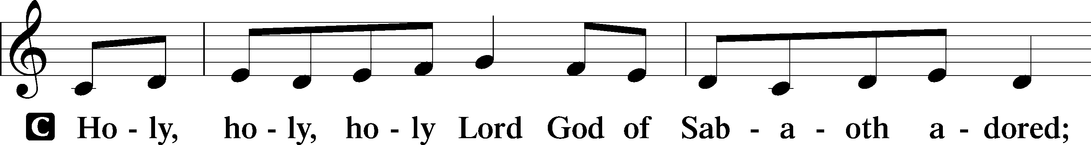
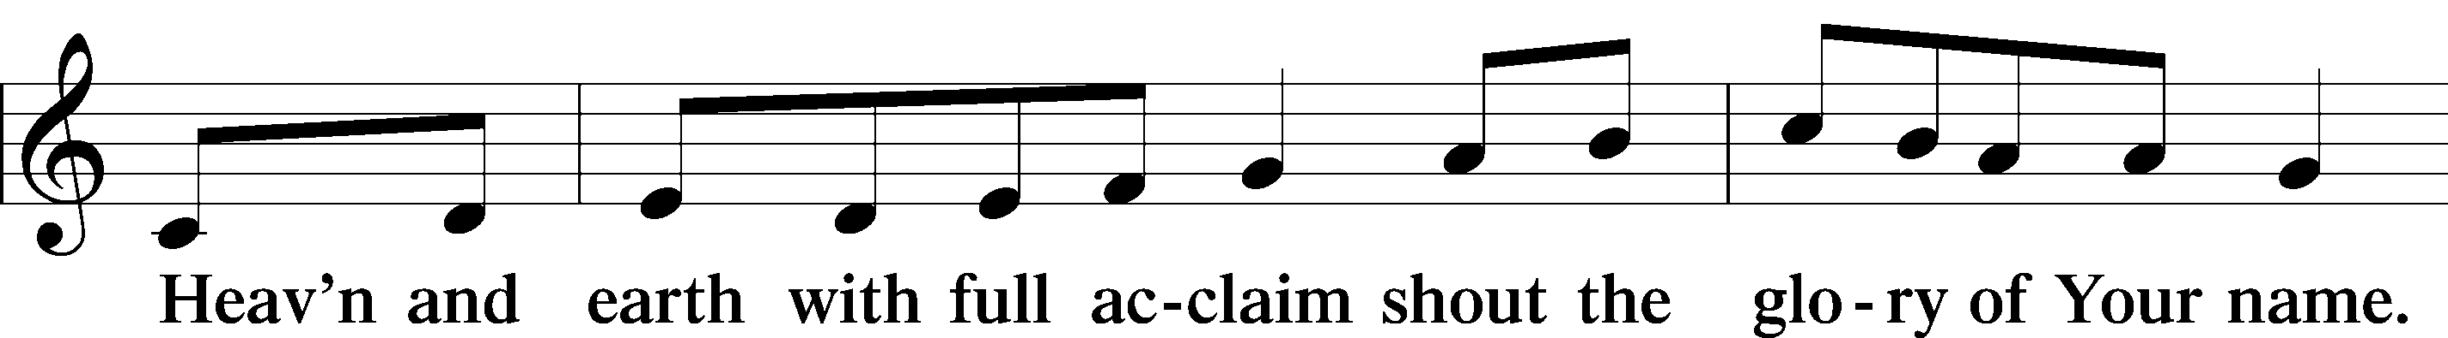
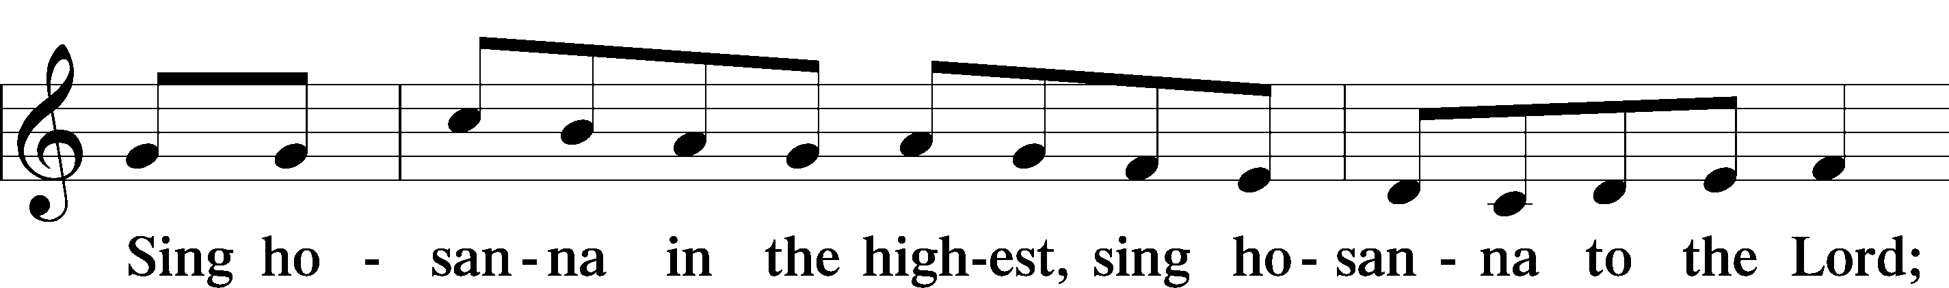
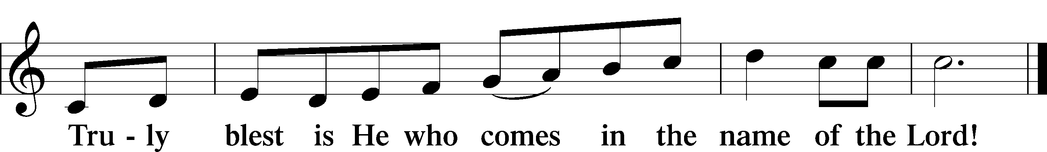

PRAYER OF THANKSGIVING
P Blessed are You, O Lord our God, king of all creation, for You have had mercy on us and given Your only-begotten Son that whoever believes in Him should not perish but have eternal life.

At Your command, Abraham prepared to offer his son Isaac as a sacrifice on the mountain; yet, in mercy You provided a ram as a substitute. We give You thanks that on Calvary You spared not Your only Son but sent Him to offer His life as a ransom for many.

As we eat and drink His body and blood, grant us, like Abraham our father, to trust in Your promise now fulfilled in Christ, the Lamb of God, who takes away the sin of the world.

THE WORDS of our LORD

P Our Lord Jesus Christ, on the night when He was betrayed, took bread, and when He had given thanks, He broke it and gave it to the disciples and said: “Take, eat; this is My T body, which is given for you. This do in remembrance of Me.”

In the same way also He took the cup after supper, and when He had given thanks, He gave it to them, saying: “Drink of it, all of you; this cup is the new testament in My T blood, which is shed for you for the forgiveness of sins. This do, as often as you drink it, in remembrance of Me.”

PAX DOMINI
P The peace of the Lord be with you always.
C Amen.

AGNUS DEI LSB 210
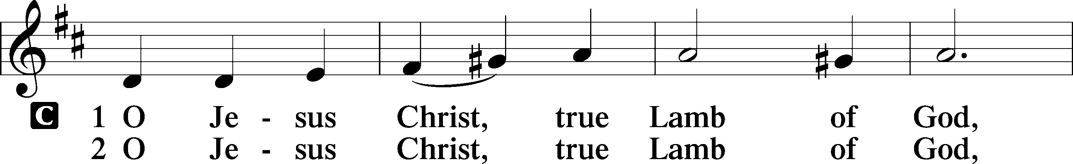
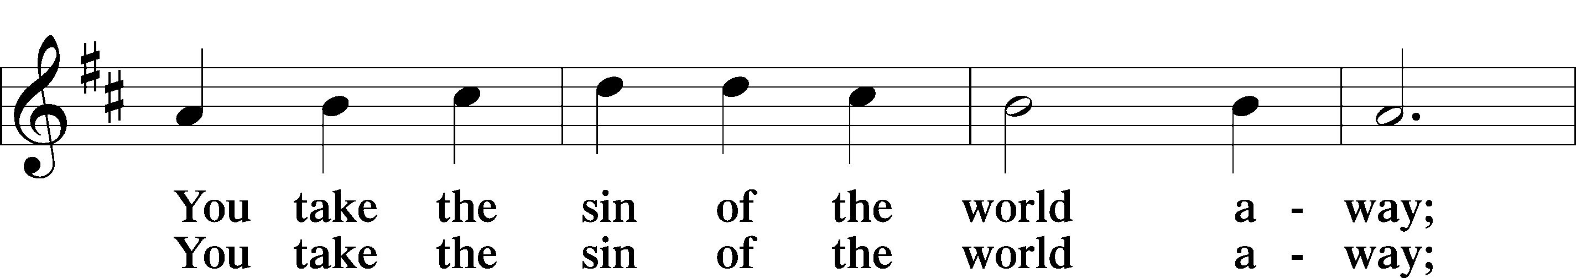
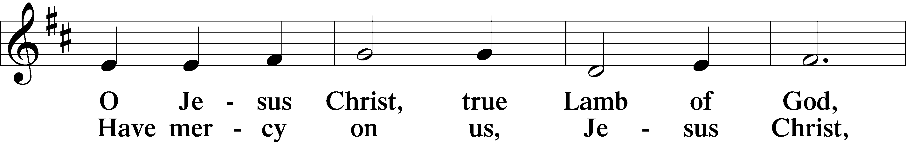
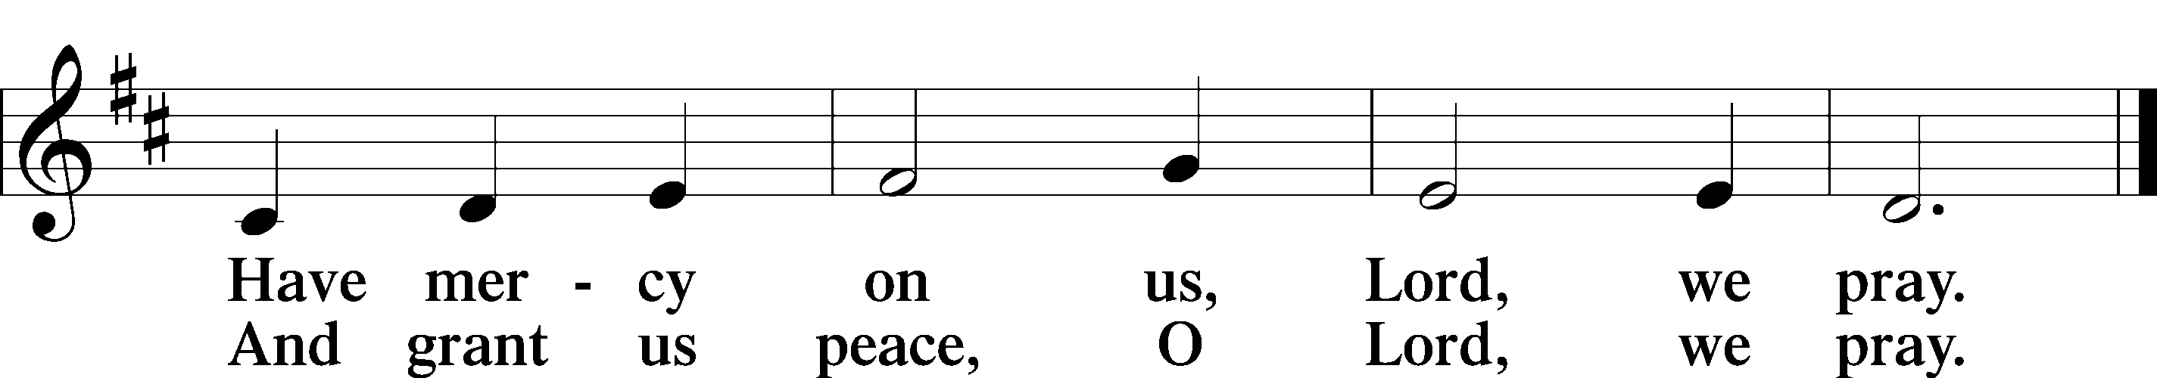

Please be Seated

The pastor and those who assist him receive the body and blood of Christ first, then Communion will be served at the rail. Ushers will help direct you forward via the center aisle; please return to your seats via the side aisles. Gluten-free bread is available for those who need it, as is non-alcoholic grape juice. Simply request either when you come forward to receive Communion.

DISTRIBUTION HYMN
O Sacred Head, Now Wounded LSB 449
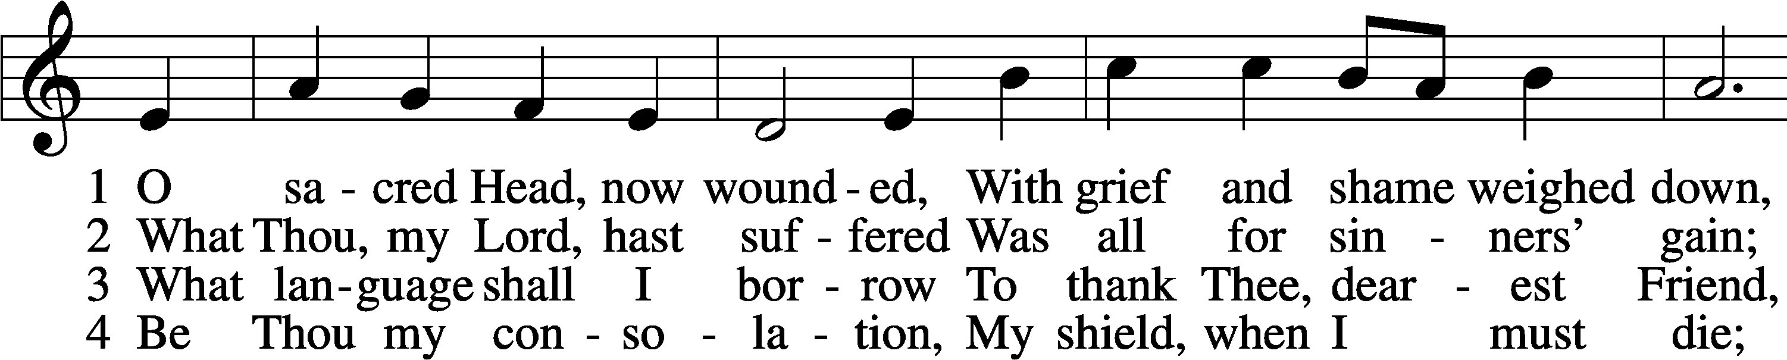
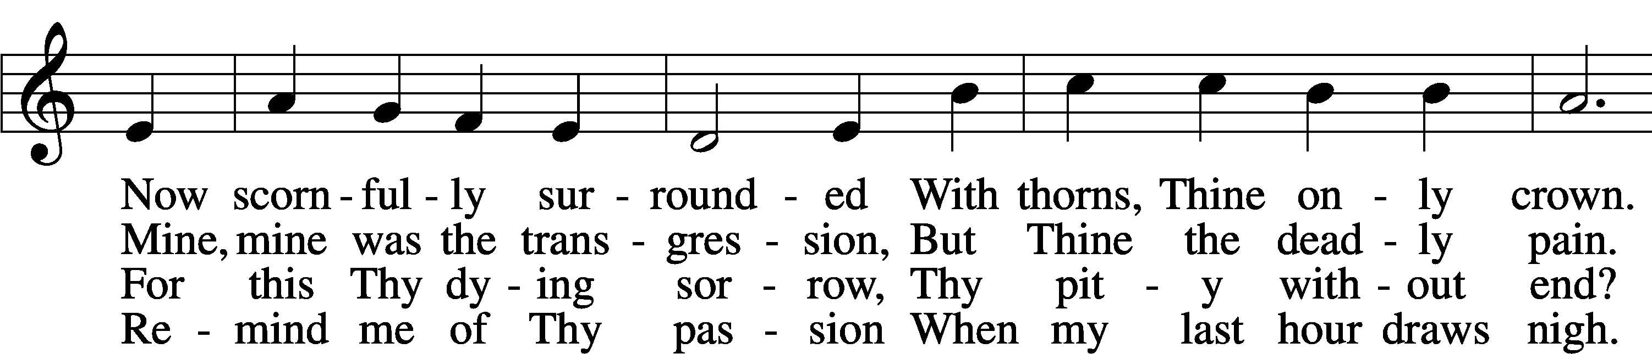
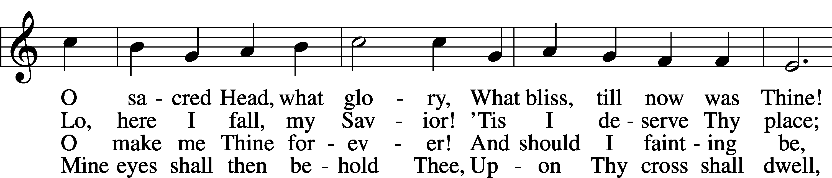
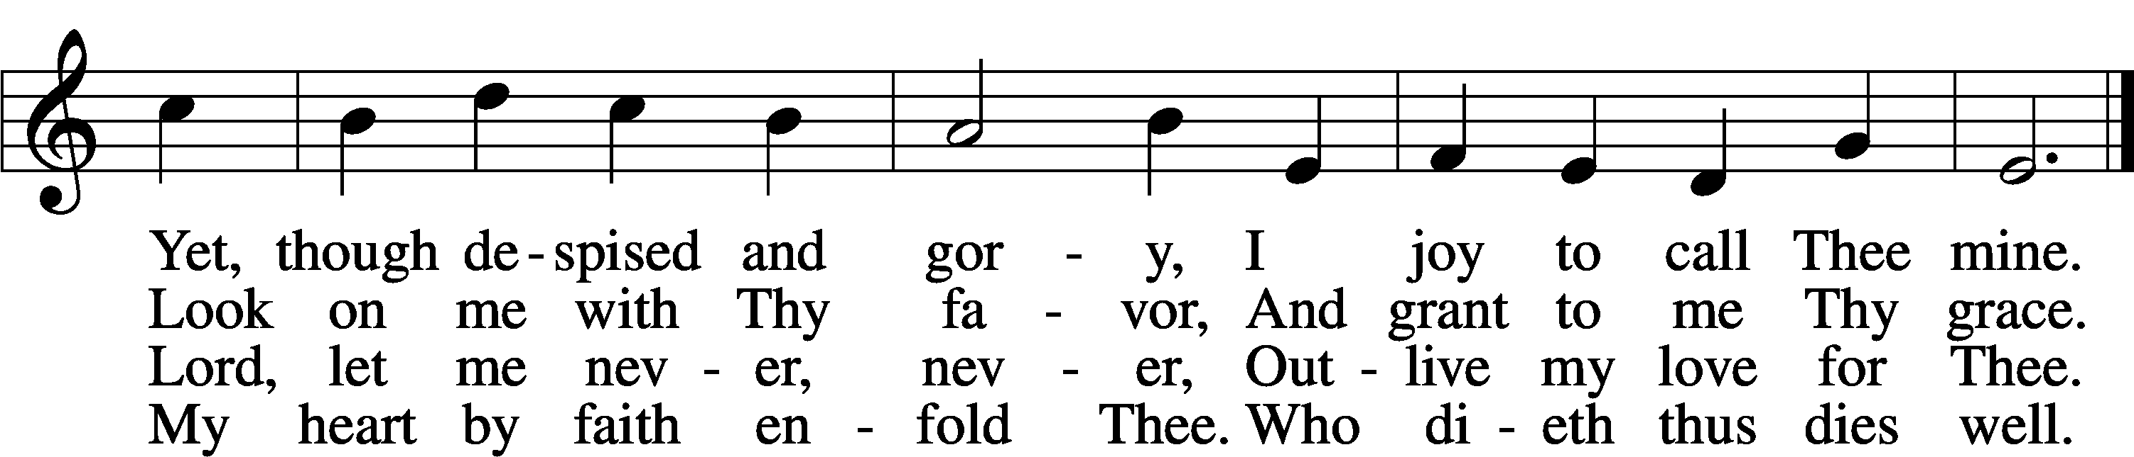

NUNC DIMITTIS LSB 211
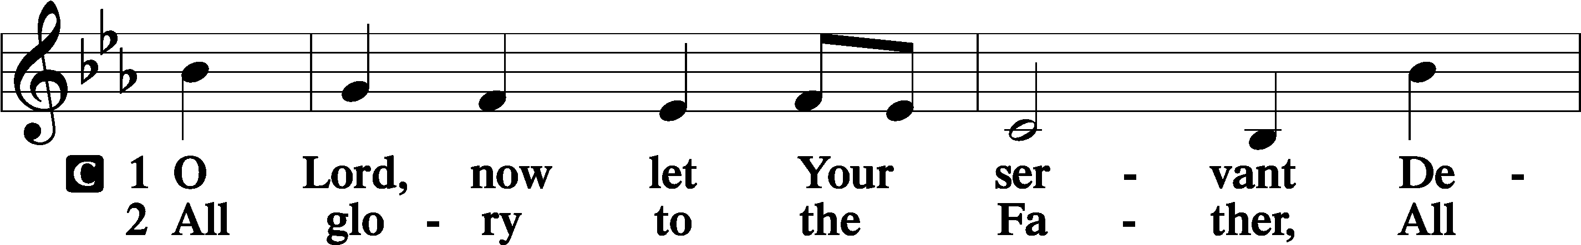
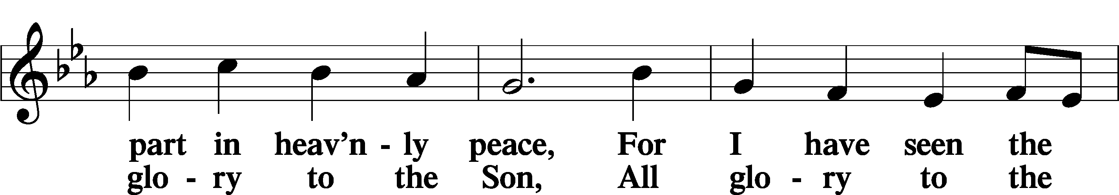
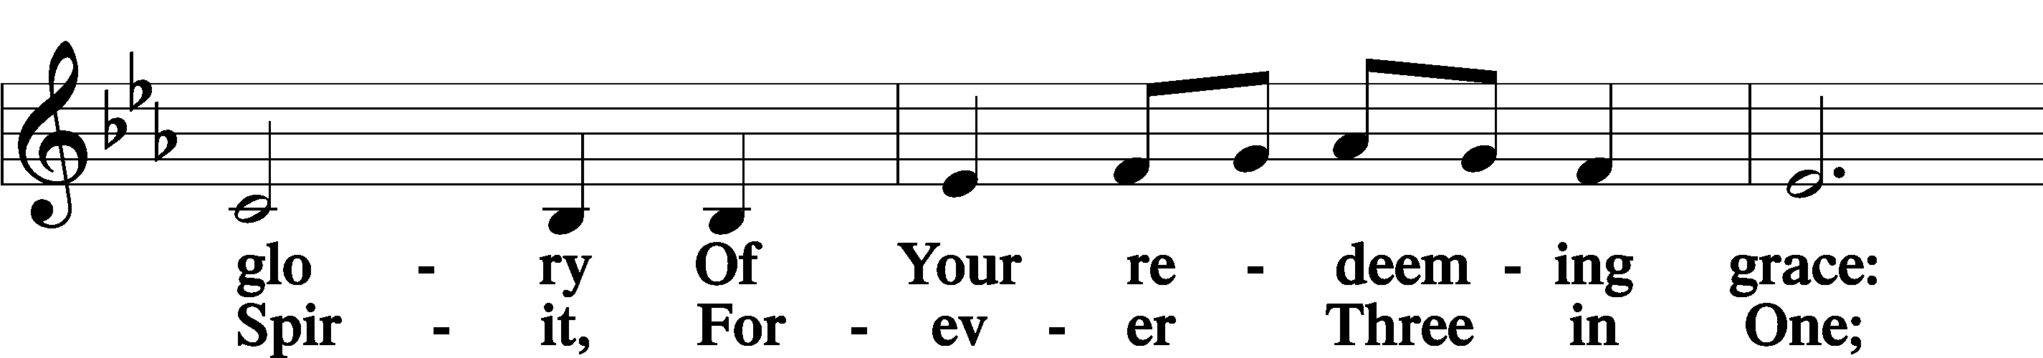
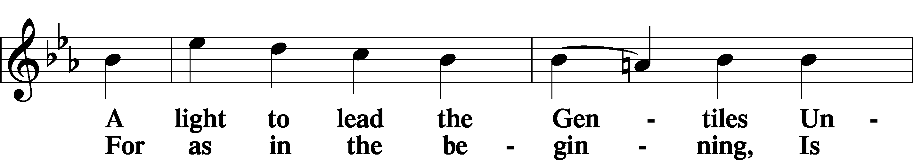
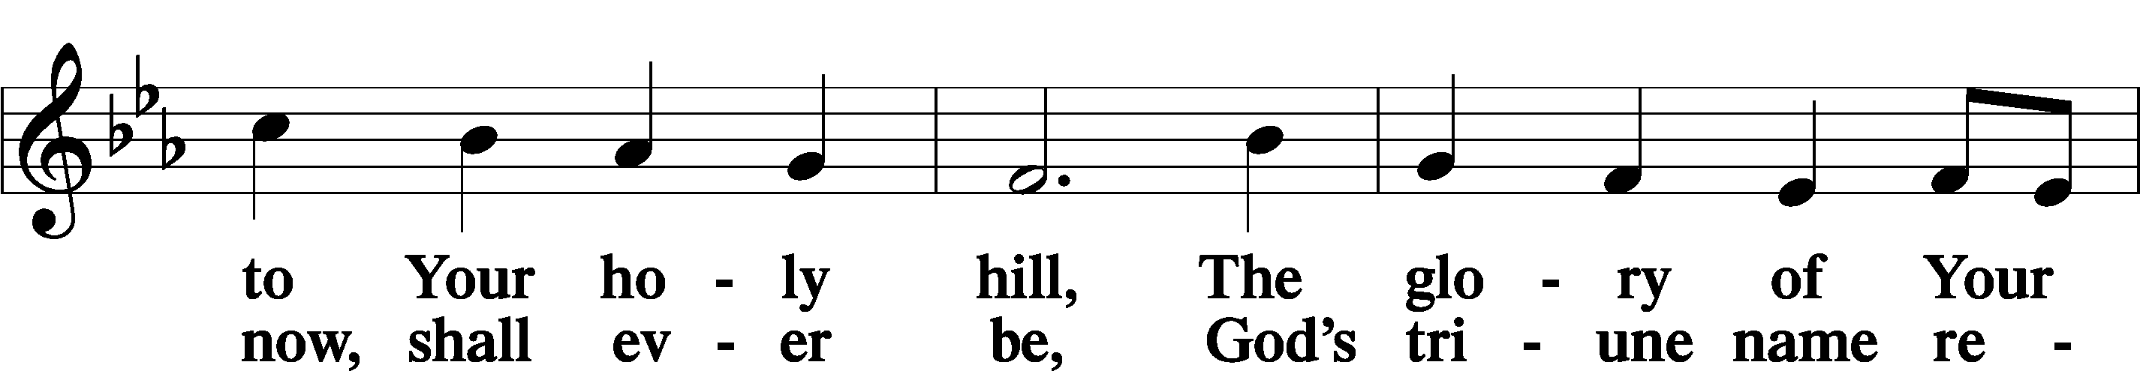
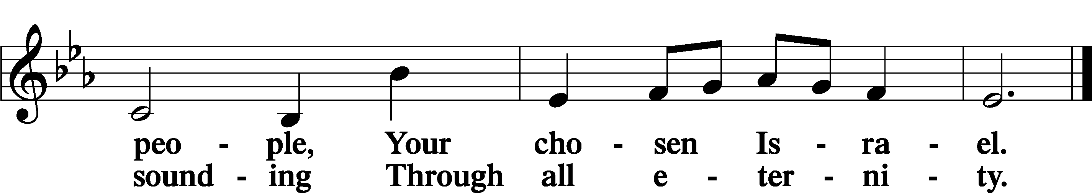

POST COMMUNION COLLECT
P Let us pray.
We give thanks to You, almighty God, that You have refreshed us through this salutary gift, and we implore You that of Your mercy You would strengthen us through the same in faith toward You and in fervent love toward one another; through Jesus Christ, Your Son, our Lord, who lives and reigns with You and the Holy Spirit, one God, now and forever.
C Amen

BENEDICAMUS LSB 212
P Let us bless the Lord.
C Thanks be to God.
BENEDICTION
P The Lord bless you and keep you.
The Lord make His face shine on you and be gracious to you.
The Lord look upon you with favor and T give you peace.
C Amen.

Please be seated

CLOSING HYMN
Abide with Me LSB 878
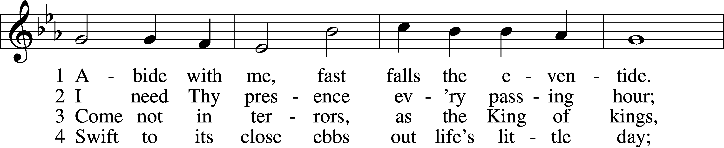
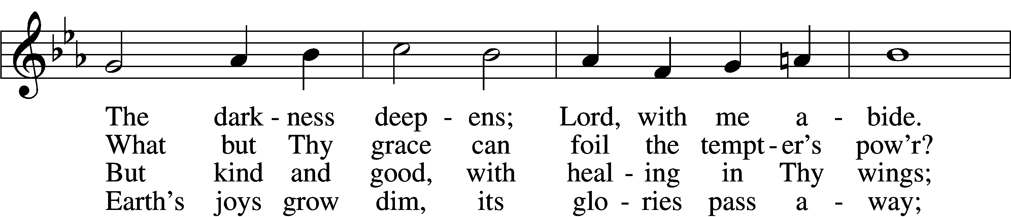
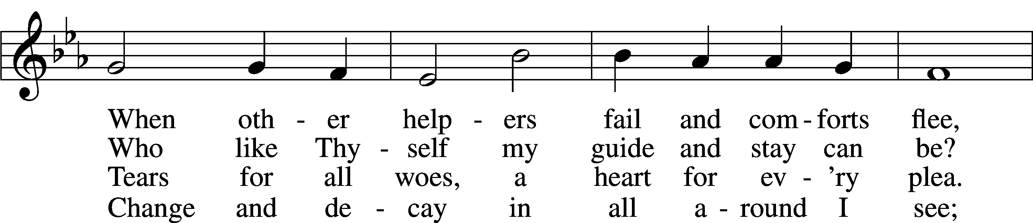
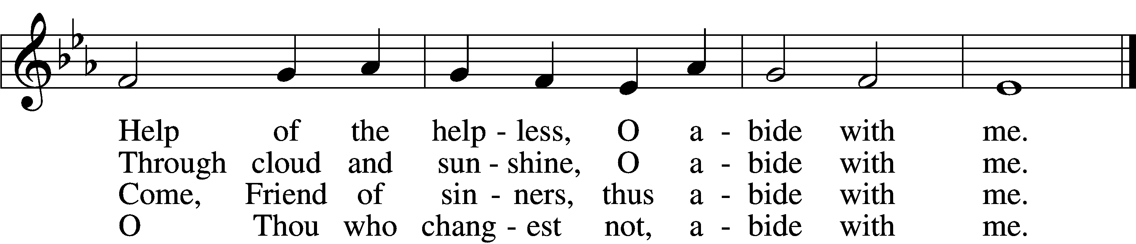
Continued on next page
5 I fear no foe with Thee at hand to bless;
Ills have no weight and tears no bitterness.
Where is death’s sting? Where, grave, thy victory?
I triumph still if Thou abide with me!

6 Hold Thou Thy cross before my closing eyes;
Shine through the gloom, and point me to the skies.
Heav’n’s morning breaks, and earth’s vain shadows flee;
In life, in death, O Lord, abide with me.

ANNOUNCEMENTS and SENDING WORDS
P We go to live for Jesus!
C We go to share His love!

Acknowledgments
Unless otherwise indicated, Scripture quotations are from the ESV® Bible (The Holy Bible, English Standard Version®), copyright 2001 by Crossway, a publishing ministry of Good News Publishers. Used by permission. All rights reserved. Created by Lutheran Service Builder. Music reproduced in this service is used with permission through: CCLI License No.1776588 and CPH – LSB Service Builder.

SERVING IN GOD’S HOUSE TODAY 2/22/2023
Pastor Rev. Ken Bernthal
Elder: Tom Raithel
Coffee & pie: Ladies Guild
Virtual Organ: Judy Stutzman

